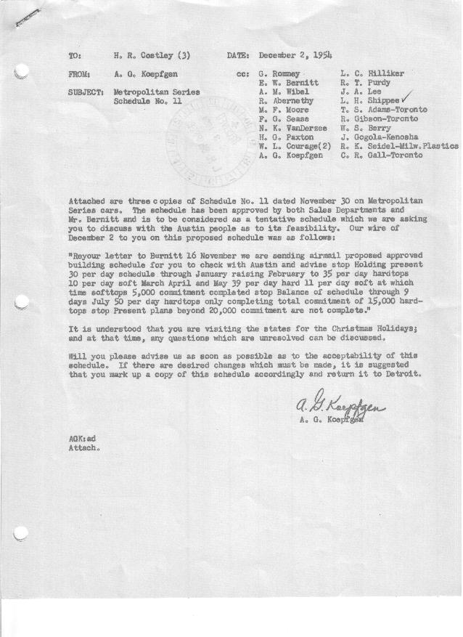

FORM PLAN 68 REV. 9-40-N.K.P PRINTED IN U.S.A

SCHEDULE NO. ______11________ DATE November 30, 1954 MONTHLY BUILDING SCHEDULE APPROVED W. L. Courage & H. G Paxton (signed)____DATE_ _12-1-54____ REVISION NO. ________________ DATE ________________ PRODUCT APPROVED_____E. W. Bernitt (signed) ___________DATE_ _12-1-54_____
Metropolitan Series Cars – Austin Motors Co. Ltd., England
DESCRIPTION | BUILT  ◻ACT EST  THRU  11-30-54 | FIRM BUILDING SCHEDULE  (FABRICATED MATERIAL RELEASE) |  |  |  |  |  |  |  |  |  |  |  |  |  |  | TENTATIVE SCHEDULE  (RAW MATERIAL RELEASED) |  |  | GRAND  TOTAL
DESCRIPTION | BUILT  ◻ACT EST  THRU  11-30-54 | MONTH December  DAYS 21 * |  |  | MONTH January  DAYS 21 |  |  | MONTH February  DAYS 20 |  |  | MONTH March  DAYS 23 |  |  | MONTH April  DAYS 18 |  |  |  |  |  | GRAND  TOTAL
DESCRIPTION | BUILT  ◻ACT EST  THRU  11-30-54 | DAILY | MONTH | CUM’L  TOTAL | DAILY | MONTH | CUM’L  TOTAL | DAILY | MONTH | CUM’L  TOTAL | DAILY | MONTH | CUM’L  TOTAL | DAILY | MONTH | CUM’L  TOTAL | DAILY | MONTH | TOTAL | GRAND  TOTAL
Nash
Hard-Top Conv. | 7131 |  | 230 | 7361 |  | 230 | 7591 |  | 366 | 7957 |  | 575 | 8532 |  | 460 | 8992
Soft-Top Conv. | 3798 |  | 0 | 3798 |  | 0 | 3798 |  | 119 | 3917 |  | 172 | 4089 |  | 115 | 4204
Total | 10929 |  | 230 | 11159 |  | 230 | 11389 |  | 485 | 11874 |  | 747 | 12621 |  | 575 | 13196
Hudson
Hard-Top Conv. | 2014 |  | 400 | 2414 |  | 400 | 2814 |  | 334 | 3148 |  | 322 | 3470 |  | 242 | 3712
Soft-Top Conv. | 315 |  | 0 | 315 |  | 0 | 315 |  | 81 | 396 |  | 81 | 477 |  | 83 | 560
Total | 2329 |  | 400 | 2729 |  | 400 | 3129 |  | 415 | 3544 |  | 403 | 3947 |  | 325 | 4272
Corporation - Total
Hard-Top Conv. | 9145 | 30 | 630 | 9775 | 30 | 630 | 10405 | 35 | 700 | 11105 | 39 | 897 | 12002 | 39 | 702 | 12704
Soft-Top Conv. | 4113 | 0 | 0 | 4113 | 0 | 0 | 4113 | 10 | 200 | 4313 | 11 | 253 | 4566 | 11 | 198 | 4764
Grand Total | 13258 | 30 | 630 | 13888 | 30 | 630 | 14518 | 45 | 900 | 15418 | 50 | 1150 | 16568 | 50 | 900 | 17468
Over/(Under) Sched. #10 | (99) |  | (60) | (159) |  |  | (159)
 |  | * was 23 days
 | Month |  | May |  |  | June |  |  | July
 | Days |  | 20 |  |  | 22 |  |  | 9
Nash
Hard-Top Conv. |  |  | 510 | 9502 |  | 707 | 10209 |  | 270 | 10479
Soft-Top Conv. |  |  | 153 | 4357 |  | 0 | 4357 |  | 0 | 4357
Total |  |  | 663 | 13859 |  | 707 | 14566 |  | 270 | 14836
Hudson
Hard-Top Conv. |  |  | 254 | 3966 |  | 393 | 4359 |  | 162 | 4521
Soft-Top Conv. |  |  | 83 | 643 |  | 0 | 643 |  | 0 | 643
Total |  |  | 337 | 4609 |  | 393 | 5002 |  | 162 | 5164
Corporation - Total
Hard-Top Conv. |  | 38 | 764 | 13468 | 50 | 1100 | 15468 | 50 | 432 | 15000
Soft-Top Conv. |  | 12 | 236 | 5000 | 0 | 0 | 5000 | 0 | 0 | 5000
Grand Total |  | 50 | 1000 | 18468 | 50 | 1100 | 19568 | 50 | 432 | 20000

